

**EC60064**

**Biomedical System Engineering and Automation**

**Experiment-5**

**Report**

Prepared by

Sai Joshitha Annareddy

21EE62R10

MTech

Control systems engineering

Question 1:

Problem Statement:

Two Vibroarthrographic (VAG) signals are given in the files vag1.dat and vag2.dat . The sampling rate is 2 kHz. Obtain and plot their power spectra (PSDs) using PYTHON.

Label the frequency axis in Hz. Compute the mean frequency as the first moment of the PSD for each signal. Compute also the variance of each PSD.For calculating PSD use FFT.

What are the units of these parameters? Compare the spectra and the parameters derived and give your evaluation of the frequency content of the signals.

Note: Data files vag1.dat and vag2.dat are available at the site

**Figures:**

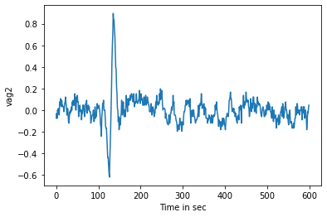

**Figure 1: signal plot of vag1**

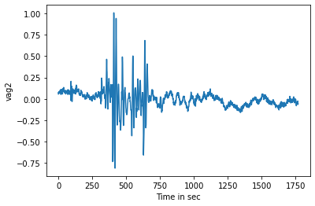

**Figure 2:signal plot of vag2**

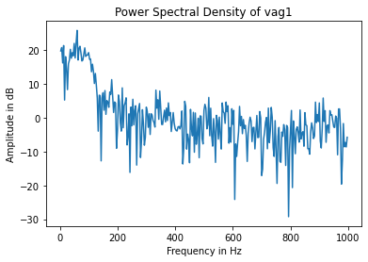

**Figure 3:power spectral density of vag1**

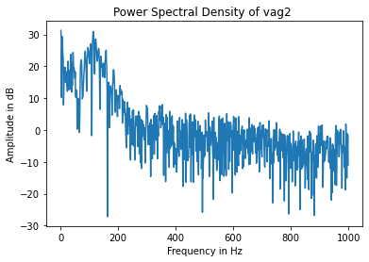

**Figure 4:power spectral density of vag 2**

Energy is sum of square of absolute values of Power spectral density.

Mean is cumulative sum of i*PSD[i] I ranging in the length of psd of a signal.

Variance is the cumulative sum of (x-mean)2*power spectral density and divide by energy of the signal

Results and Discussions:

Vag 1 :

Energy: 71820100

Mean: (-0.013258214593355602+0.0011903288659067162j)

Variance: (-3.274882470416152+0.13288182111047628j)

Vag 2 :

Energy: 1846844845

Mean: (-0.00195711574979964+3.267753734536043e-05j)

Variance: (-1.5472873335812958+0.020091596632319405j)

**Question 2:**

Problem Statement:

Using python, prepare a signal that contains the sum of two cosine waves of equal amplitude at **40 Hz** and **45 Hz**.

Let the sampling rate be **1kHz**.

(a) Compute the power spectrum of the signal with a rectangular window of duration **2 s**.

(b) Compute the power spectrum of the signal with a Hamming window of duration **2s**.

(c) Compute the power spectrum of the signal with a rectangular window of duration **0.5 s**.

(d) Compute the power spectrum of the signal with a Hamming window of duration **0.5 s**.

To obtain the power spectrum, you may take the FFT and square the result.

Compare the spectra obtained in parts (a) - (d) and comment upon their similarities and/or differences.

In order to visualize the differences clearly, use 2,048-point FFTs and plot the logarithm of the magnitude-squared spectra with an expanded scale from 0 to 100 Hz only. Be sure to label the frequency axis in Hz.What should the ideal spectrum look like?

Figures:

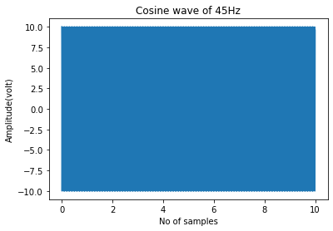

Figure 5: cosine wave of 45 hz

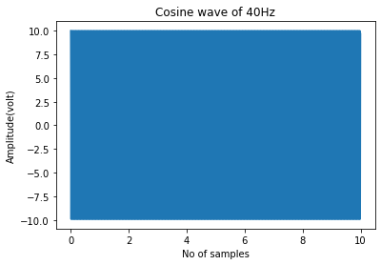

Figure 6:cosine wave of 40hz

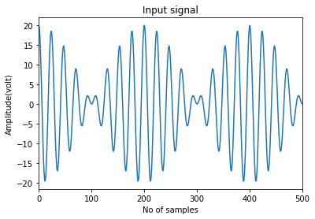

Figure 7:Input signal

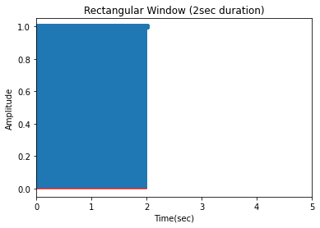

Figure 8:Rectangular window of 2 sec

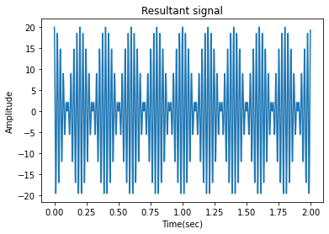

Figure 9:Resultant signal after passing input signal through rectangular window of 2 secs

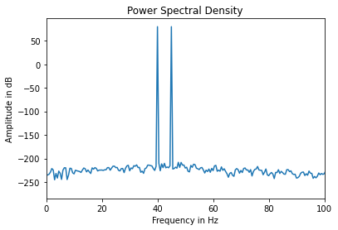

Figure 10:Power spectral density of input signal after passing through rectangular window of 2 sec(combination of two cosine waves)

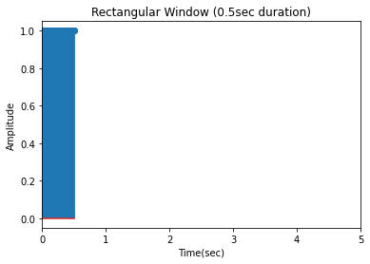

Figure 11:Rectangular window of 0.5 sec

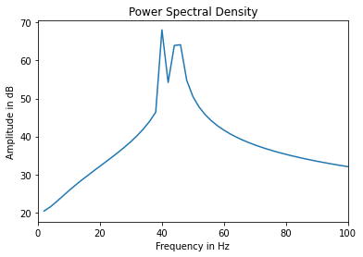

Figure 12:power spectral density of resultant signal after passing through rectangular window of 0.5sec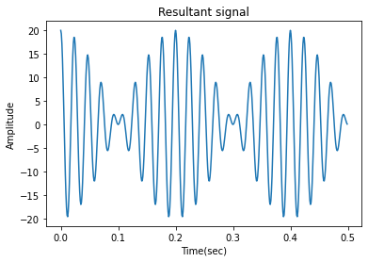

Figure 13:Resultant signal after passing through rectangular window of 0.5 sec

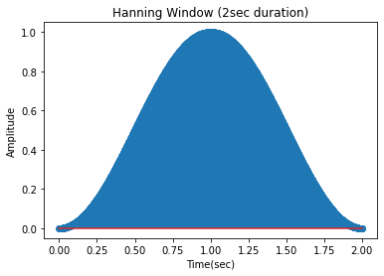

Figure 14:Hanning window of 2sec duration

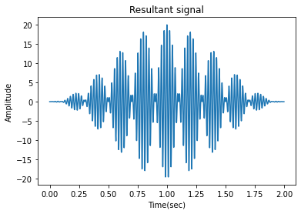

Figure 15:Resultant signal after passing input signal to hanning window of 2 sec

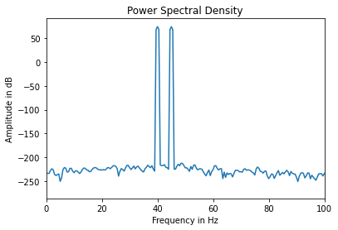

Figure 16:power spectral density of resultant signal after passing through hanning window of 2 sec

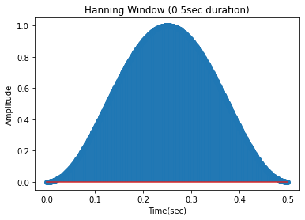

Figure 17:Hanning window of 0.5 sec

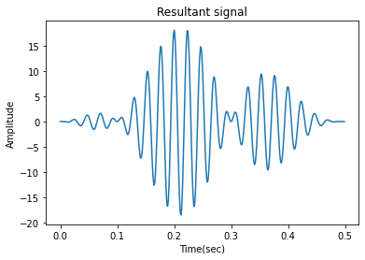

Figure 18:After passing input signal through 0.5sec hanning window

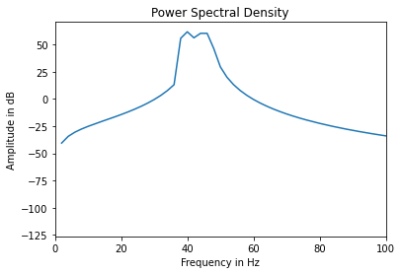

Figure 19:Power spectral density after passing through hanning window of 0.5sec

Results and Discussions:

The graphs for part a to d are given above.

By comparing all the above power spectral density

For the rectangular window, the spikes are sharp compared to the hamming window and hamming window provides better separation of side lobes. Reduced duration of window losses frequency resolution. Irrrespective of window the spikes become wider and as a result in these case hamming window with 0.5 sec they almost merge. If two frequencies are closer for then for smaller window width there looks like single spike.

So the ideal power spectrum should have two spectral frequencies at 40 and 45 hand rectangular window has smaller main lobe width than hamming window.

The window choice depends on duration of signal or frequency resolution.